Setting Your Out of Office Assistant
Email

To set your Out of Office Assistant, follow the instructions below:
- Log on to the Outlook Web App

https://connect.emailsrvr.com
Login with your email address and email password

- Click on Options

- Click on See All Options

- Click on Tell People You’re on Vacation
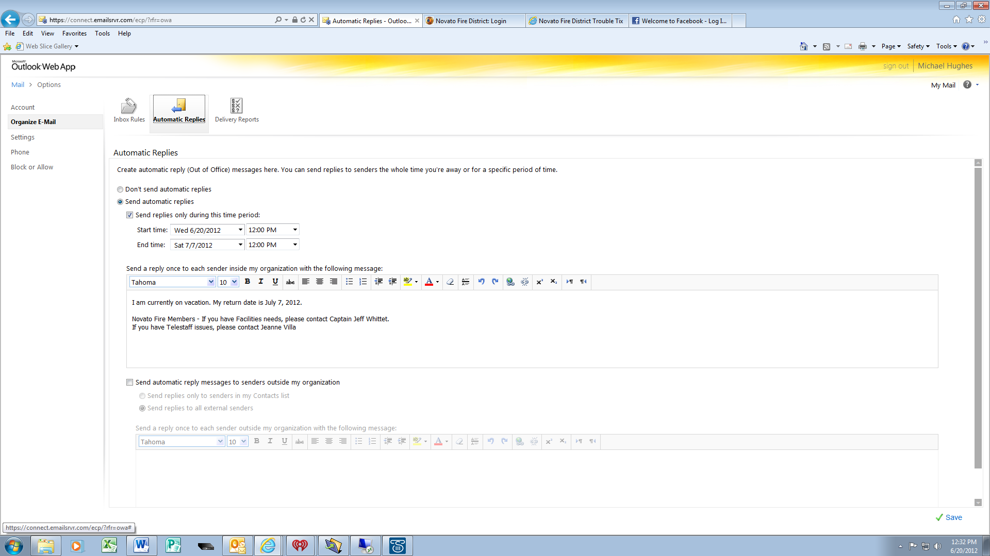
- Click on Send Automatic Replies and complete the fields and type a message.

- Click on Save in the lower right.

- When you return to the office, repeat steps 1-6, only choose “Don’t Send Auto Replies”, then Save.

