Setting Your Out of Office Assistant
Using Outlook Desktop

To set your Out of Office Assistant using the Desktop version of Outlook,
follow the instructions below:

Office 2007:

- Open Outlook
- Click on Tools in the upper toolbar
- Click on Out of Office Assistant
- Complete the fields
- Click OK
- To Turn off Automatic Replies, follow steps 1-5, choosing “Do Not Send Out of Office auto-replies”

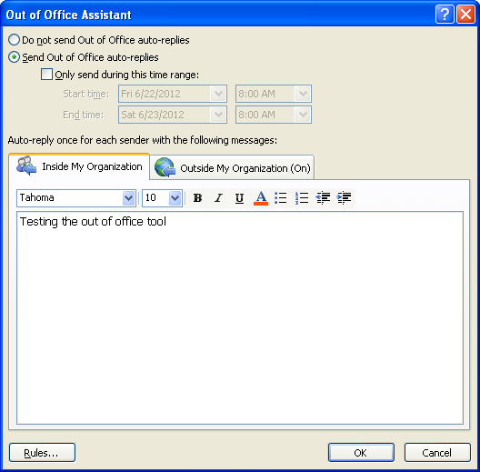

Office 2010:
- Open Outlook
- Click on File
- Click on Automatic Replies (Out of Office)
- Complete the fields
- Click OK
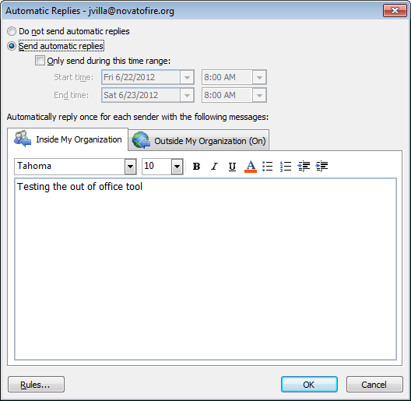
- To Turn off Automatic Replies, follow steps 1-5, choosing “Do Not Send Automatic Replies”

